SIMATS ENGINEERING

ASSESSMENT TOOL 2(MEDIUM)
COURSE NAME: Ethical Hacking COURSE CODE: ITA1401
_______________________________________________________________________________________
COURSE OUTCOME COVERED
CO3:Analyze network services using port scanning, ping sweeps, and enumeration techniques across different operating systems to identify vulnerabilities.(BT4)

Assessment Tool Weightage: 30%

Duration: 90 min Total Marks: 50
__________________________________________________________________________ Code of Conduct:
I M.SHARMILA(192572139) certify that this submission is my original work and that I have
adhered to the guidelines specified for this assessment.
I understand that any violation of academic integrity rules will result in disciplinary action.
Signature of the student:M.SHARMILA

Port Scanning Challenge
1. Using Nmap, perform a security assessment on the server 192.168.1.20. Identify all open ports and running services. Analyze the purpose of each discovered service and recommend security measures to reduce the attack surface of the system.

Security Assessment of Server Using Nmap

Target IP: 192.168.1.20

Tool Used: Nmap 7.99

Objective :
To perform a security assessment of the server 192.168.1.20 using Nmap, identify the open ports and running services, analyze the purpose and security risks of each service, and recommend suitable security measures to reduce the attack surface.

Host Discovery , Scanning All TCP Ports :

Command 1 : nmap -sn 192.168.1.20
Command 2 : nmap -p- 192.168.1.20

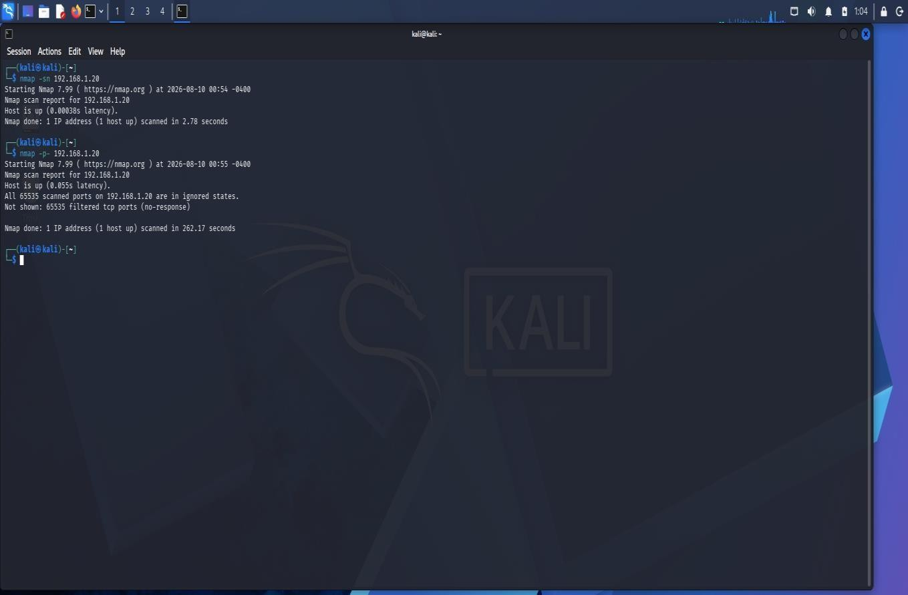

Result :
The Nmap host discovery scan confirmed that the target server 192.168.1.20 is active and reachable on the network. A full TCP port scan was performed on all 65,535 TCP ports of the target server. All 65,535 ports were reported as filtered, and no open TCP ports were identified.
Service and Version Detection

Command 3 : nmap -sV 192.168.1.20

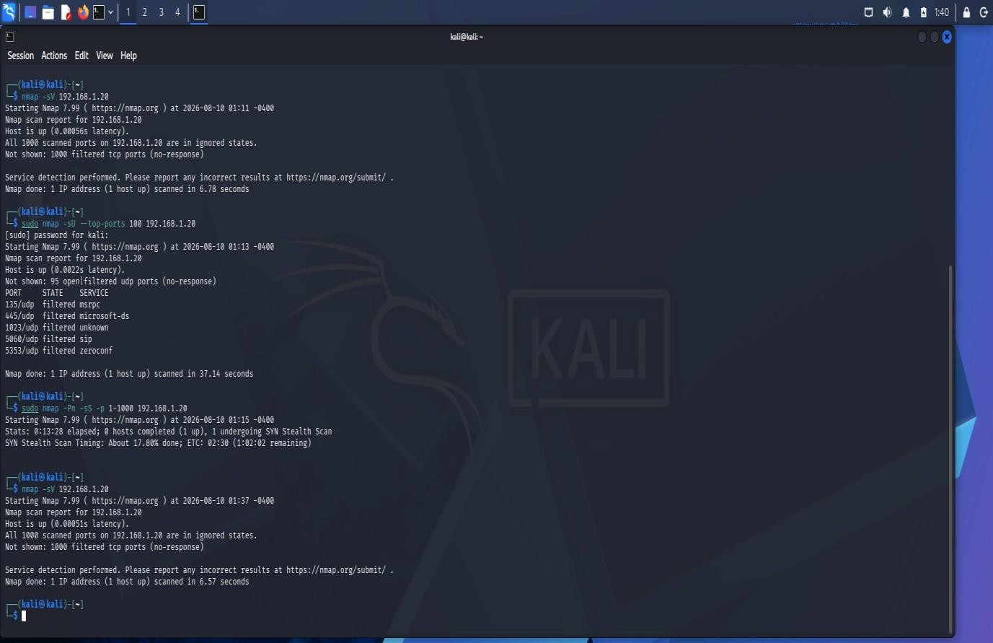

Result:
Nmap service and version detection was performed on the target. The scan checked the 1,000 most commonly used TCP ports. All 1,000 ports were reported as filtered, and no accessible TCP services or service versions were identified.

UDP Scan

Command 4 : nmap -sV 192.168.1.20

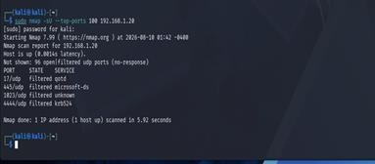
Result:
A UDP scan was performed against the 100 most commonly used UDP ports. Nmap reported five ports as filtered: 135, 445, 1023, 5060, and 5353. The remaining 95 ports were reported as open\ filtered because no response was received. No UDP port was confirmed as open.
Security Analysis :
- No confirmed open TCP ports : The full TCP scan did not identify any confirmed open TCP ports. All 65,535 TCP ports were reported as filtered.
- No confirmed open UDP ports : The UDP scan did not identify any confirmed open UDP ports. Several UDP ports were reported as filtered or open\filtered.
- Network filtering : The consistent filtered results suggest that a firewall or network-level packet-filtering mechanism is preventing direct access to the target's ports.

Security Recommendations :
- Disable unnecessary services so that unused network services are not exposed.
- Use firewall rules to allow only required ports and trusted sources.
- Restrict administrative access to authorized users and networks.
- Keep operating systems and services updated with the latest security patches.
- Use strong authentication for administrative services.
- Monitor firewall and server logs for suspicious connection attempts.
- Regularly perform Nmap scans to identify newly exposed ports.
- Apply the principle of least privilege to users and services.

Attack Surface Reduction :

The attack surface of the server can be reduced by exposing only the network services that are necessary for its intended function. Unnecessary services should be disabled, and firewall rules should restrict access to required services. Administrative services should be accessible only to authorized users or trusted networks. Regular security scans should also be performed to detect unintended changes in the server's exposed services.
2. Using Nikto, assess the web server hosted on 192.168.1.30. Identify potential web server misconfigurations, outdated components, or exposed files and directories. Discuss the security risks associated with your findings and suggest appropriate mitigation strategies.
Nikto Web Server Security Assessment

Target: 192.168.1.30

Tool: Nikto

Objective :
The objective of this assessment is to analyze the web server hosted on 192.168.1.30 using the Nikto web server vulnerability scanner. The assessment focuses on identifying potential web server misconfigurations, outdated software components, exposed files and directories, and other security weaknesses.

Lab Environment

Scanning machine: Kali Linux

Target: Metasploitable 2

Tool: Nikto

Kali IP: 192.168.56.101

Initial Target Verification

Command 1 : ping -c 4 192.168.1.30
- Then we checked the HTTP/HTTPS ports : nmap -p 80,443 -sV 192.168.1.30
- Ports 80 and 443 were shown as filtered, so the web server could not be identified.
- The lab target was Metasploitable 2, we checked its IP using : ifconfig ➢ Metasploitable initially had 192.168.56.102.

Resolving the IP Conflict

We checked the Host-Only network using : sudo arp-scan --interface=eth1 192.168.56.0/24

Result : The scan showed that two devices were using 192.168.56.102, causing an IP conflict.
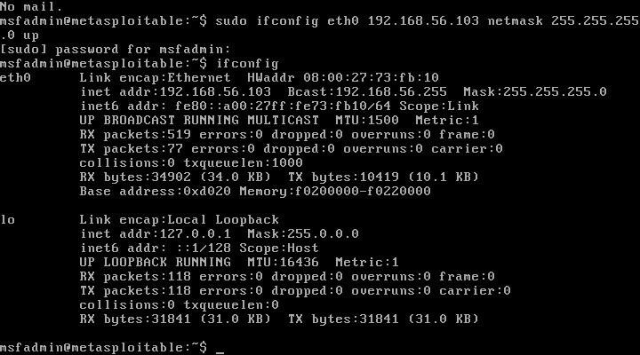

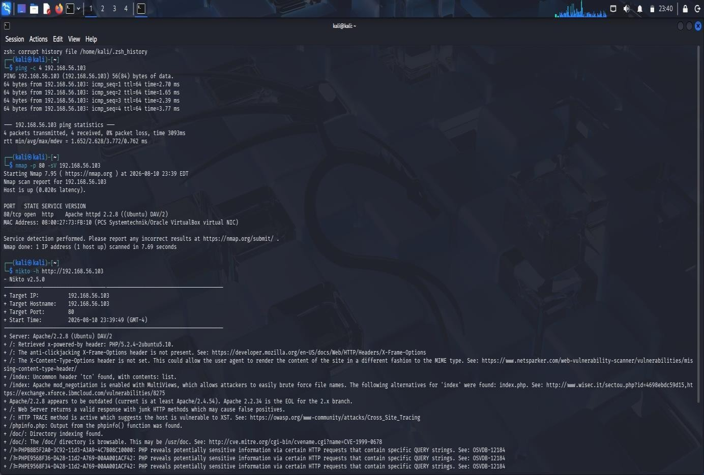

Web Server Identification

Nmap was used to identify the web service:

Command 2 : nmap -p 80 -sV 192.168.56.103

Result : 80/tcp open http Apache httpd 2.2.8 ((Ubuntu) DAV/2). Thus, the target was running Apache HTTP Server 2.2.8.
Nikto Scan :

Command 3 : nikto -h http://192.168.56.103

Nikto completed the scan and reported 27 findings.

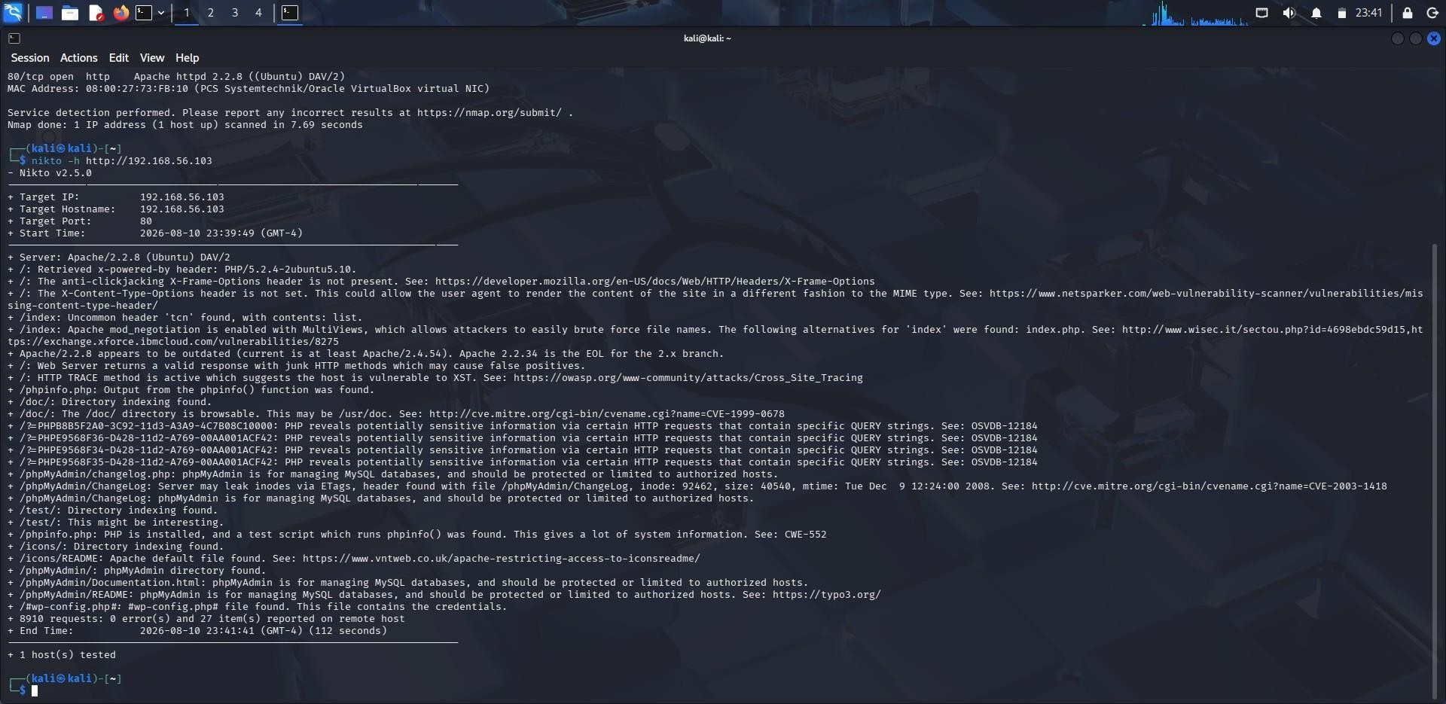

Major Findings

- Outdated Apache 2.2.8
- Outdated PHP 5.2.4
- Missing X-Frame-Options
- Missing X-Content-Type-Options
- Apache MultiViews enabled
- HTTP TRACE method enabled
- /phpinfo.php exposed
- Directory indexing enabled for /doc/, /test/, and /icons/
- /phpMyAdmin/ exposed

Security Risks

- The outdated Apache and PHP versions may contain known vulnerabilities and increase the possibility of attacks.
- The exposed phpinfo.php can reveal detailed server and PHP configuration information.
- Exposed phpMyAdmin provides access to a database administration interface and should not be publicly accessible without proper restrictions.
- Directory indexing can allow attackers to discover files and resources.
- Missing security headers and enabled HTTP TRACE also increase the server's attack surface.

Mitigation Strategies

- Upgrade Apache and PHP to supported versions.
- Remove unnecessary backup, test, and documentation files.
- Remove or restrict access to phpinfo.php.
- Restrict phpMyAdmin to authorized users/networks.
- Disable directory listing where unnecessary.
- Disable HTTP TRACE.
- Disable MultiViews if not required.
- Configure security headers such as X-Frame-Options and X-Content-Type-Options.
- Regularly patch and scan the web server.

Conclusion

The Nikto assessment successfully identified several security weaknesses in the Metasploitable web server. The major concerns were outdated Apache/PHP versions, exposed phpMyAdmin and configuration-related files, directory indexing, and missing security headers. The assessment demonstrated how Nmap can first identify the web service and Nikto can then perform a more detailed security assessment.
3. Using Netcat (nc), investigate the host 192.168.1.40 by connecting to open ports and collecting available service banners. Analyze the information obtained and explain how attackers could use banner information during the reconnaissance phase of an attack.

Service Banner Enumeration Using Netcat

Objective

To investigate the target host using Netcat (nc), identify open ports, collect available service banners, and understand how banner information can help attackers during reconnaissance.

Procedure

- Target identification: The IP 192.168.1.40 given in the question was not reachable, so a local Metasploitable 2 lab machine was used as the authorized target. Its IP address was identified as:
192.168.56.102
- Connectivity test : ping -c 4 192.168.56.102

Result : The host responded successfully with 0% packet loss, confirming connectivity between Kali Linux and Metasploitable 2.

3. Open-port scanning using Netcat : nc -zv 192.168.56.102 1-1000

Port | Port name | Port | Port name
21 | FTP | 80 | HTTP
22 | SSH | 111 | SunRPC
23 | Telnet | 139 | NetBIOS
25 | SMTP | 445 | Microsoft-DS
53 | DNS | 512 | exec

4. Banner collection:

- FTP banner was collected using : nc -v 192.168.56.102 21
Result : 220 (vsFTPd 2.3.4)
- SSH banner was collected using : nc -v 192.168.56.102 22
Result : SSH-2.0-OpenSSH_4.7p1 Debian-8ubuntu
- HTTP was also accessed using : nc -v 192.168.56.102 80

Result : The connection confirmed that the HTTP service was open.

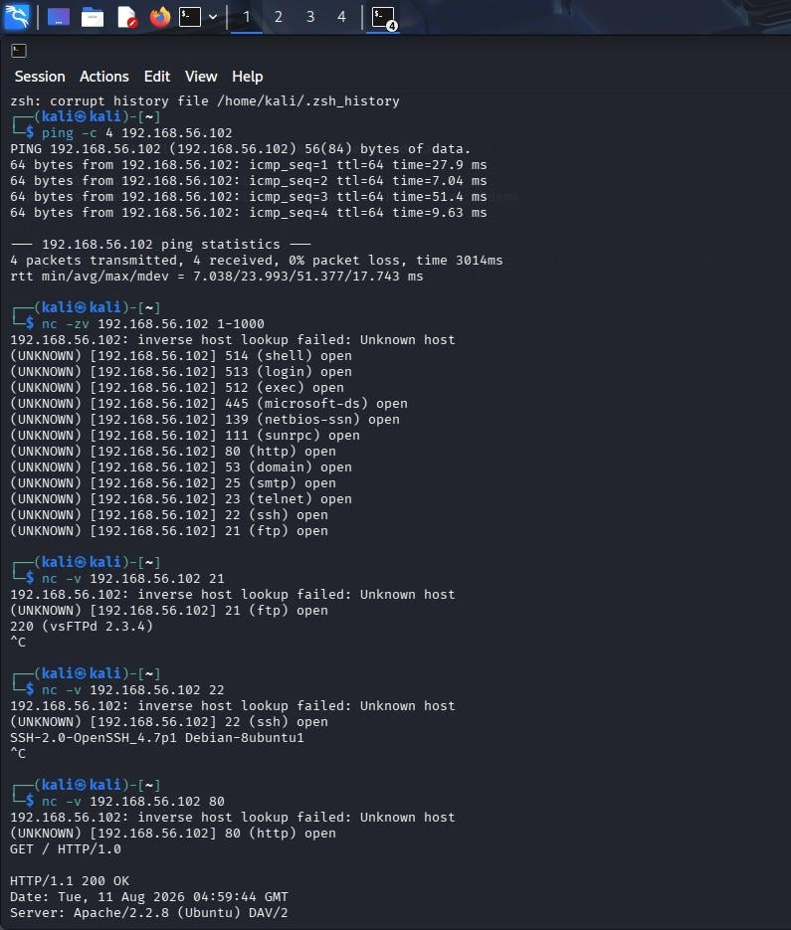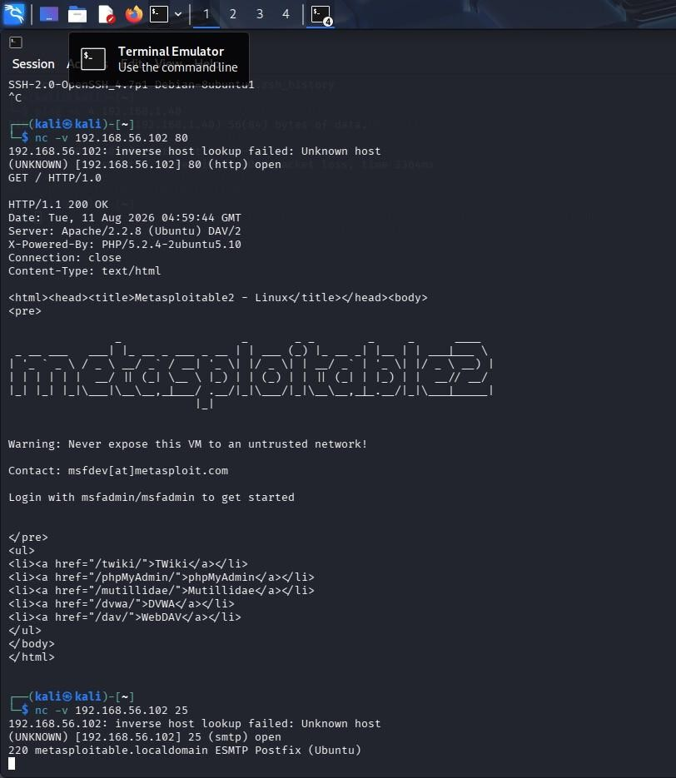

Analysis

The banners revealed the service names, software products, and versions running on the target. An attacker could use this information during reconnaissance to identify technologies and compare their versions against publicly known vulnerabilities. This can help them select potential attack paths.

Conclusion

Netcat successfully identified multiple open services and collected FTP and SSH service banners from the Metasploitable 2 host. The exercise demonstrated how exposed service information can provide useful reconnaissance information to attackers. Administrators should keep services updated, disable unnecessary services, restrict access to exposed ports, and minimize unnecessary version disclosure.
4. Using Telnet, examine the server 192.168.1.50 to determine whether remote administration services are accessible. Identify any security concerns related to the discovered services and recommend more secure alternatives where appropriate.
Remote Administration Service Assessment Using Telnet

Objective :

To examine the Metasploitable server and determine whether remote administration services are accessible using Telnet, identify security concerns, and recommend secure alternatives.

Scanning machine: Kali Linux Tool : Telnet

Target: Metasploitable 2

Target IP: 192.168.56.102

Procedure :

- Identified the IP address of the Metasploitable machine.
- From Kali Linux, tested the Telnet service : telnet 192.168.56.102 23
- The connection was successful and the Metasploitable login prompt was displayed.
- Tested RDP : telnet 192.168.56.102 3389
- The connection was refused, indicating that RDP was not accessible.

Commands :

- telnet 192.168.1.50 22
- telnet 192.168.1.50 23
- telnet 192.168.1.50 3389

Results :

Port | Service | Result
23 | Telnet | Accessible
3389 | RDP | Not Accessible
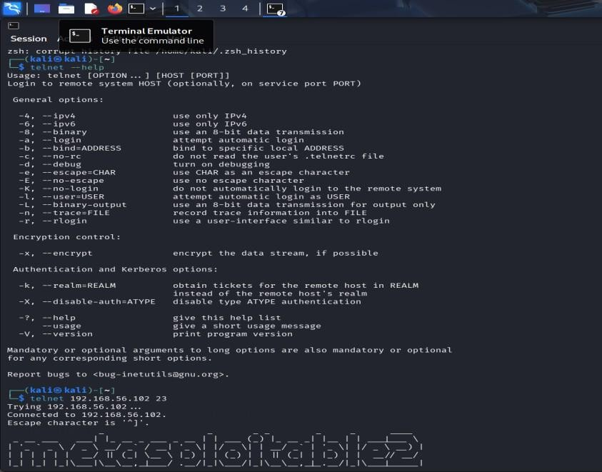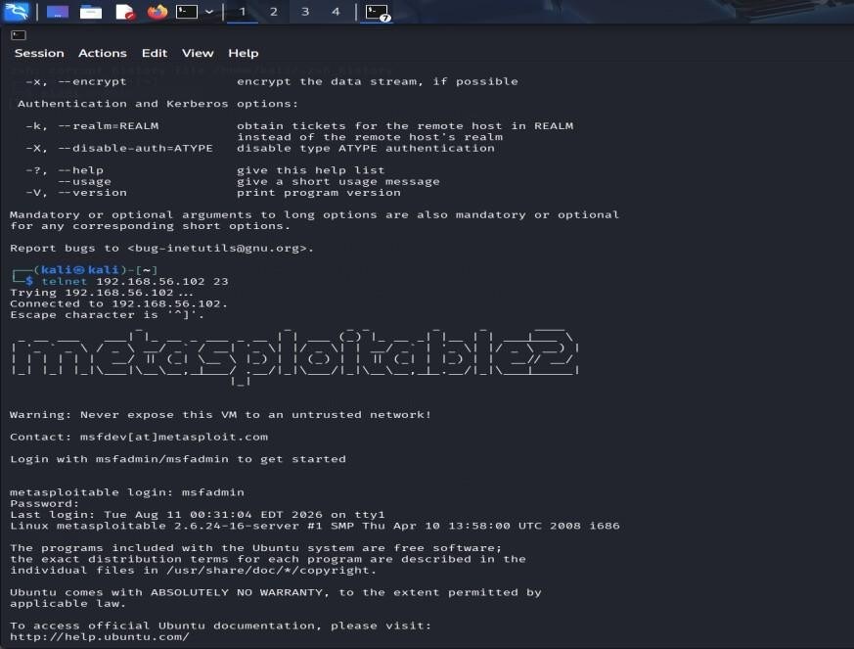

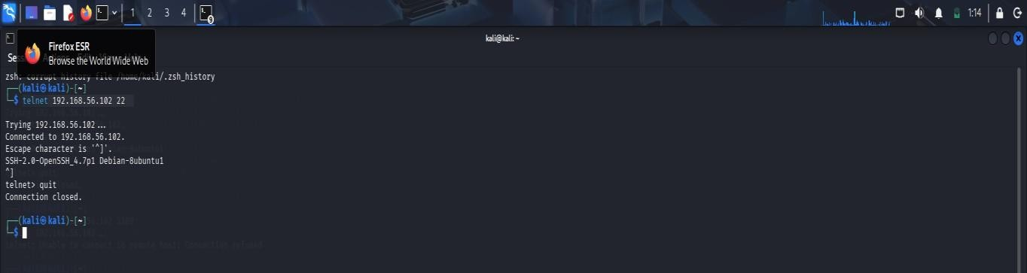

Security Concerns

- Telnet is insecure because it transmits login credentials and session data without encryption.
- An attacker monitoring the network could potentially capture sensitive information.
- Exposed remote-administration services can increase the risk of unauthorized access.
Recommendations

- Disable Telnet wherever possible.
- Use SSH (Port 22) for secure, encrypted remote administration.
- Restrict remote-administration services using firewalls and trusted networks.
- Use strong authentication and avoid exposing management services unnecessarily.

Conclusion

The assessment confirmed that Telnet on port 23 was accessible on the Metasploitable server, while RDP on port 3389 was not accessible. Telnet presents a significant security weakness because it does not provide encrypted communication. SSH is recommended as the safer alternative.
5. Using Netdiscover, perform host discovery on the network segment 192.168.1.1–50. Identify active hosts on the network and analyze how the discovered information could assist an attacker in planning further enumeration or exploitation activities..

Host Discovery Using Netdiscover

Objective :
To perform host discovery on the authorized network segment and identify active hosts using Netdiscover.

Tools Used
Kali Linux , Netdiscover , VirtualBox
Procedure
- Checked the available network interfaces using : ip addr
- Identified eth1 as the lab interface with IP address 192.168.56.101/24.
- Performed host discovery using : sudo netdiscover -i eth1 -r 192.168.56.0/24
- Waited for the scan to finish and recorded the discovered IP addresses, MAC addresses, and vendor information.

Commands :
        - ip addr
        - sudo netdiscover -i eth1 -r 192.168.56.0/24 | tee netdiscover_result.txt

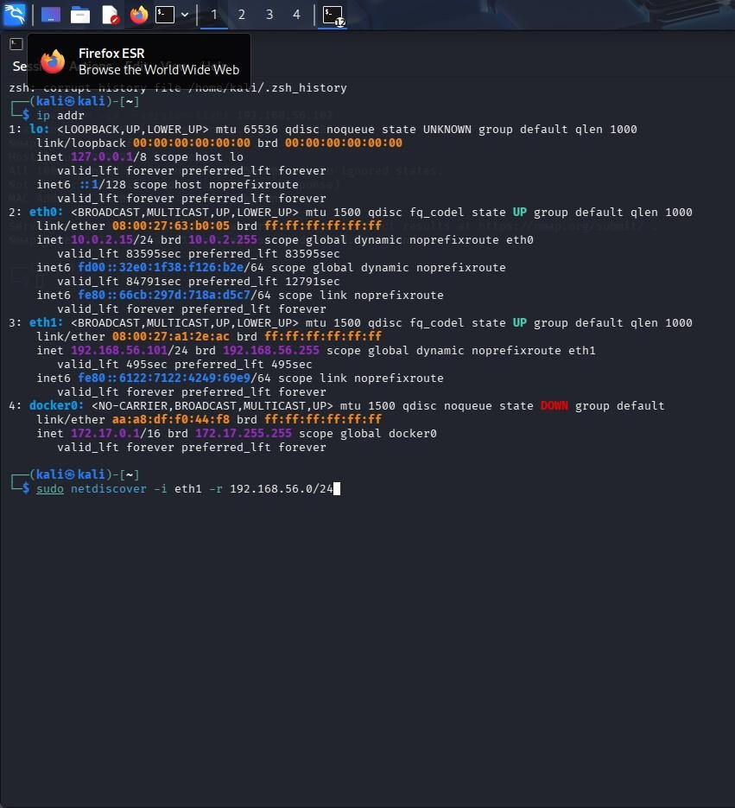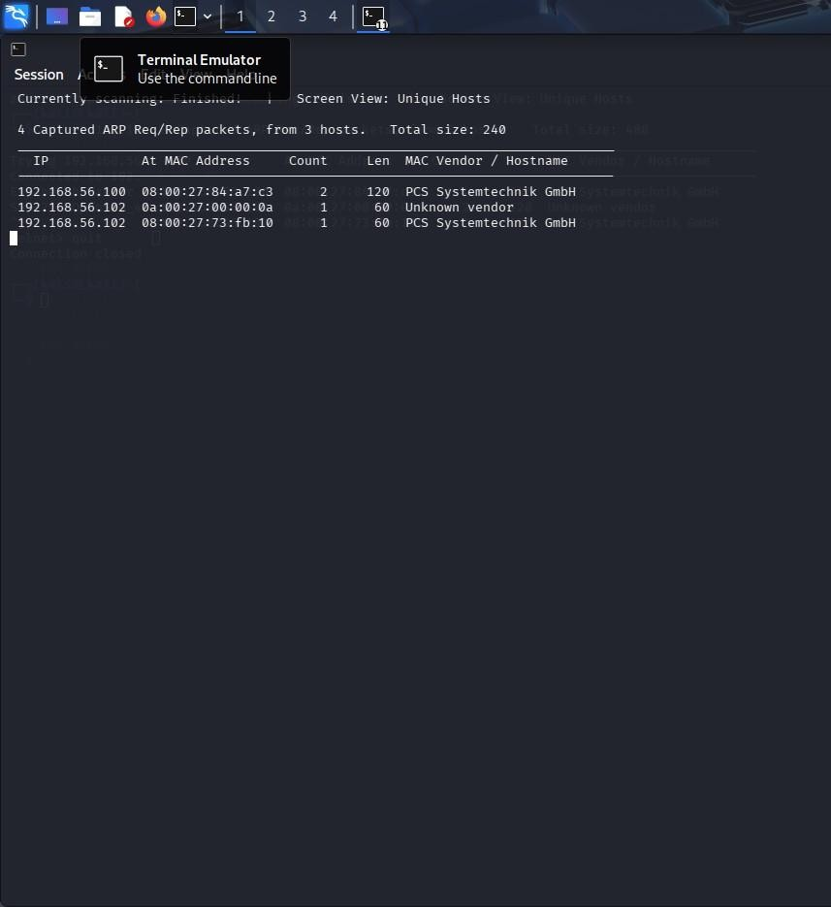
Results :

IP Address | MAC Address | Vendor
192.168.56.100 | 08:00:27:84:a7:c3 | PCS Systemtechnik GmbH
192.168.56.102 | 08:00:27:00:00:0a | Unknown Vendor
192.168.56.102 | 08:00:27:73:fb:10 | PCS Systemtechnik GmbH

Netdiscover reported:
- 4 Captured ARP Req/Rep packets, from 3 hosts.
- The repeated 192.168.56.102 entry represents the same IP appearing with different MAC information in the virtualized lab environment.

Security Analysis
The discovered IP addresses identify active systems on the network. MAC addresses and vendor information provide additional information about their network interfaces. An attacker could use this information during reconnaissance to identify potential systems for further authorized service and vulnerability enumeration.

Conclusion
Netdiscover successfully identified active hosts on the lab network and displayed their IP, MAC, and vendor information. The experiment demonstrates how host discovery can provide an initial network map for security assessment.

Q.No | Identification of  Port Scanning  Factors(25) | Analysis(25) | Linkage(20) | Application(20) | Clarity(10) | Marks
1
2
3
4
5

Signature of Faculty Total Avg :

